%Problem 5.6

for vds = 0:.001:0.05

%For Vgs = 0.5

id05 = (0.005\*(0.5-0.5))\*vds;

%For Vgs = 1

id1 = (0.005\*(1-0.5))\*vds;

%For Vgs = 1.5

id15 = (0.005\*(1.5-0.5))\*vds;

%For Vgs = 2

id2 = (0.005\*(2-0.5))\*vds;

%For Vgs = 2.5

id25 = (0.005\*(2.5-0.5))\*vds;

plot(vds,id05,'b--o')

hold on

plot(vds,id1,'r--\*')

plot(vds,id15,'g--o')

plot(vds,id2,'y--\*')

plot(vds,id25,'c-\*')

end

xlabel('Vds');

ylabel('Id');

legend('Vgs = 0.5','Vgs = 1','Vgs = 1.5','Vgs = 2','Vgs = 2.5');

title('Id vs. Vds');

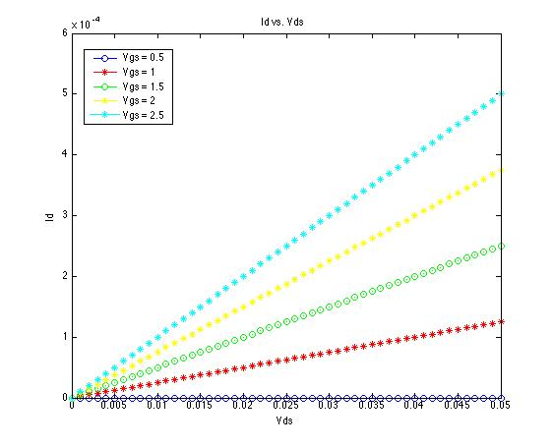

%Problem 5.28

vt = 0.4;

geom = 1E-3;

vds = 1;

for vgs = 0:0.1:1.8

if (vgs <= 0.4)

id = 0;

elseif (vgs > 0.4) && (vgs<=1.4)

%saturation

id = (0.5)\*geom\*(vgs-vt).^2;

else

%triode

id = geom\*((vgs-vt)-(0.5\*vds))\*vds;

end

plot(vgs,id,'b-\*')

hold on

end

xlabel('Vgs [V]');

ylabel('Id [microAmps]');

legend('Vgs');

title('Id vs. Vgs');

